Restricting data with where clause

Relational Operators

- >
- >=
- <
- <=
- =
- != or <> or ^= (For Not Equal To)
- Between lower value And higher value
- Not Between lower value And higher value
- IN (List of Values)
- NOT IN (List of Values)

Logical Operators

- AND
- OR
- NOT

- AND operator will check conditions in combination

select * from emp
where job = 'CLERK' AND sal < 1000

- OR operator will check conditions in isolation

select * from emp
where job = 'MANAGER' or sal < 1000

If AND OR are together then AND is executed first then OR

select * from emp
where job = 'MANAGER' or job = 'CLERK' and sal < 1000

Parentheses will override the default precedence

select * from emp
where (job = 'MANAGER' or job = 'CLERK' ) and sal < 1000

Complex And / Or conditions:

Select * from Products2
where (country = 'India' and sales <= 500) OR (country = 'France' and sales >= 1200);

Dealing with Redundant Conditions:

Asia Table → Display the records from Asia table which will satisfy all the following 4 conditions as per each county.
- India records of year 2018 of Amount > 15000
- China records of year 2018 of Amount < 20000
- Singapore records of year 2018 of Amount > 30000
- Malaysia records of year 2018 of Amount > 40000

Mentioning the year condition again and again for every country’s conditions.

Select * from Asia
where (country = 'India' and Amount > 15000 and YOT = 2018)
Or
(country = 'China' and Amount < 20000 and YOT = 2018)
Or
(country = 'Singapore' and Amount > 30000 and YOT = 2018)
Or
(country = 'Malaysia' and Amount > 40000 and YOT = 2018);

Mentioning the year condition only once!!!!

Select * from Asia
where (YOT = 2018) And
(
(country = 'India' and Amount > 15000)
Or
(country = 'China' and Amount < 20000)
Or
(country = 'Singapore' and Amount > 30000)
Or
(country = 'Malaysia' and Amount > 40000)
);

Between Operator

select * from emp
where sal between 1250 And 3000;

(1250 and 3000 will be inclusive)

select * from emp
where sal Not between 1250 And 3000;

(1250 and 3000 will be exclusive)

Between works with Dates and Strings as well!!

In Operator

select * from emp
where job In ('CLERK', 'MANAGER');

In is equivalent to logical Or operator

Special Attention → Not In

select * from emp
where job Not In ('CLERK', Null, 'MANAGER');
-- No rows shown, entire condition becomes false

Not In is equivalent to logical And operator

Retrieving NULL VALUES

IS NULL and IS NOT NULL operator

To display records where comm. is blank

select * from emp
where comm is null

To display records where some comm. is provided.

select * from emp
where comm is not null

String with '' (Single Quotes Opened and Closed) and Nulls:

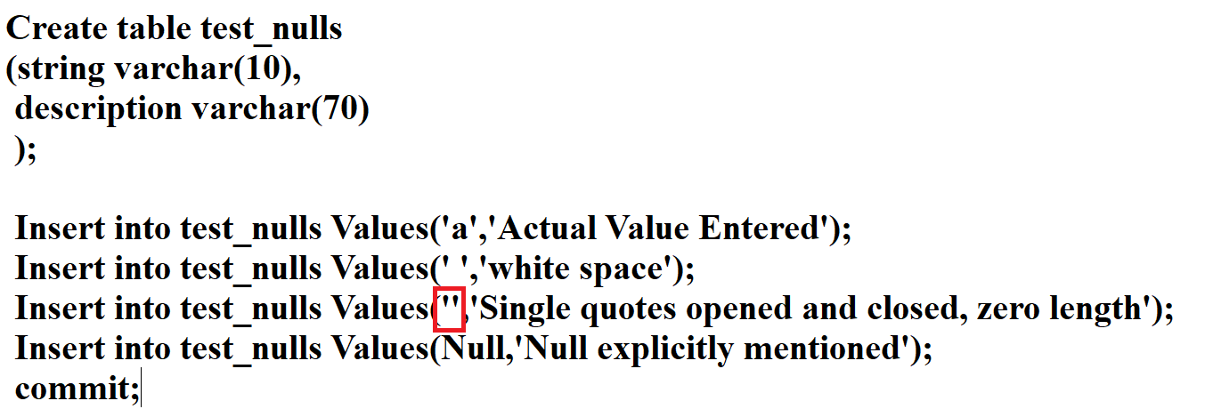

select * from test_nulls;

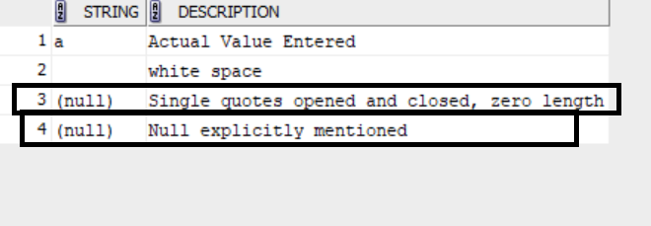

select * from test_nulls
where string is null; --?????

select * from test_nulls
where string is not null; --?????

Pattern Matching Operator LIKE

To replace any character and any number of characters use %

To display all the records where name starts with S

select * from emp
where ename like 'S%'

To replace particular number of characters use _ (Underscore)

To display records where there are exactly 3 characters before 01

select * from pcodes
where code like '___01';

To display the records where the 3rd character is %

select * from pcodes1
where code like 'AB\%Q1' ESCAPE '\';

Expression and Text Functions:

Expressions with columns of table-

select ename, sal, sal * 12 from emp;

Dual table – Meant for calculations (DUAL table is owned by SYS user which contains one column and one row)

Select 2 + 3 from dual;
Sorting

Order by clause is used for Sorting data ascending or descending

3 data types can be sorted – String, Number and Date

Default is Ascending (Asc)
Reverse sorting is by Desc clause

Single Column Sorting

select * from emp
order by ename;

OR

select * from emp
order by ename asc;

select * from emp
order by sal desc;

Multi- Column sorting

Sort the data as per the deptno. Within each deptno the records have top be sorted from highest to lowest sal.

select * from emp
order by deptno, sal desc;

In Order by clause the column position number or label can also be given

Select ename, job, sal
From emp
Order by 2 desc; -- Since the job is on the second position

select ename,sal, sal * 12 as Annual, job from emp
order by Annual desc

Conditional SQL Functions:

CASE

Acting like a Switch Case

select ename, job, case job
when 'CLERK' then 'C'
when 'ANALYST' then 'A'
when 'MANAGER' then 'M'
else
'Z'
end as "G"
from emp;

Acting like a If…Else if …..Else block

select ename, sal, case
when sal >= 5000 then 'First'
when sal >= 3000 then 'Second'
when sal >= 2000 then 'Third'
when sal >= 1000 then 'Fourth'
else
'Last'
end "SClass"
from emp

Database oriented example:

Here the code values from Air_Codes table are elaborated with full forms using case:

select code, case code
When 'L-N' Then 'London to New York'
When 'P-M' Then 'Paris to Mumbai'
When 'S-C' Then 'Singapore to Copenhagen'
Else
'Domestic Flight'
end "Details"
from Air_Codes;

Example of Nested Case

select ename, sal, comm,
case sal
when 5000 then
case
when comm is null then 'X'
when comm is not null then 'Y'
end
when 3000 then
case
when comm is null then 'P'
when comm is not null then 'Q'
end
when 1600 then
case
when comm is null then 'K'
when comm is not null then 'L'
end
end
"Remarks"
from emp;

Multiple Updates using case statement:

update emp
set sal = Case
when sal >= 5000 then 8000
when sal >= 3000 then 7000
else
6000
End;

NULLS in Expressions

    - NVL
    - Coalesce

NVL – Converts a null into a number
NVL(Expression, Value if Null)

select ename,sal + comm "Total" from emp -- Logically wrong

select ename,sal + nvl(comm,0) "Total" from emp

Coalesce (Suitable for more than 2 expressions)

It returns the first not null value amongst the given values.

select * from identification;

select empid,ename,
coalesce(passport_number, license_number,pan,credit_card_number,
account_number,'INVALID') "FOUND"
from identification;

Concatenation:

Concatenation is done by ||

select ename || job from emp;

Literal Characters – They are characters to be repeated for each row.

select ename || ' works in the job ' || job as "Details" from emp

Concat – (Works with 2 parameters only)
select concat(empno,ename) from emp

To use Concat with more than 2 parameters use pipe (||) for joining more than two parameters.

